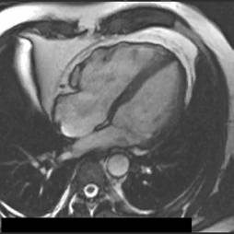

*Core Competency in Cardiac MRI 2021*

Date: Thursday 17th and Friday 18th June 2021

Venue: Virtual

Fees:£275

**APPLICATION FORM:**

**Please complete all details, and return to NECMR admin (**[**Alison.lee@nhct.nhs.uk**](mailto:Alison.lee@nhct.nhs.uk)**) via e-mail. Payment of course fees will be arranged when completed application received.**

|  |  |
| --- | --- |
| **First Name (s)** |  |
| **Surname** |  |
| **Address for correspondence** |  |
| **Telephone number** |  |
| **E-mail address** |  |
| **Deanery** |  |
| **Stage of training, e.g ST3** |  |
| **MRI experience** |  |
| **Date of application** |  |

Course Contact:

Dr Alison FC Lee,

Consultant Cardiologist

Northumbria Healthcare NHS Trust

Cardiology Dept

North Tyneside General Hospital

Rake Lane,North Shields. NE29 8NH

Tel: 0191 293 2701 Sec (Colette Burkhard)

E-mail : [alison.lee@nhct.nhs.uk](mailto:alison.lee@nhct.nhs.uk)

colette.burkhard@nhs.net